Lab 4 Fluid Navigation

## 1. Introduction

Fluid navigation refers to the concept of seamless and intuitive movement within a user interface or digital platform. It focuses on creating a smooth and effortless experience for users as they navigate through different sections, features, or pages of an application or website.

By implementing fluid navigation, designers and developers aim to create a user experience that feels natural and effortless, enabling users to focus on their tasks or content without being hindered by complex or cumbersome navigation structures.

This project is about designing interface for a guide app which helps people learn better about the fourth floor of Jishi Building under the concept of fluid navigation.

## 2. Interface demonstration

Following are descriptions of different pages in the app and how the concept of fluid navigation is used in each page. All these pages are designed with Modao.

### 1) Main page

The main page consists of two parts: a map of the fourth floor of Jishi Building and brief information of several frequently visited rooms.

The map (the map in the picture is not the real one) is visually appealing, clear, and easily readable. It uses distinct colors and symbols to represent different rooms, and it implements interactive features such as zooming and panning, allowing users to explore the map at different levels of detail. It also enables gestures or controls for intuitive navigation on touch devices, such as pinch-to-zoom and swipe gestures.

The list of frequently visited rooms, on the other hand, owns a separate section on the main page. It uses clear and concise room names or icons to represent each location for quick recognition. For each room, it includes clickable buttons that lead users to more detailed information about that room. What’s more, in has enabled smooth scrolling within the frequently visited rooms section, allowing users to easily browse through the list.

The navigation bar in the bottom of each page will be discussed later.

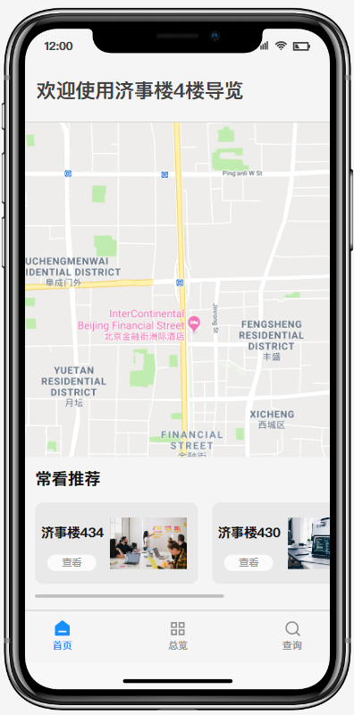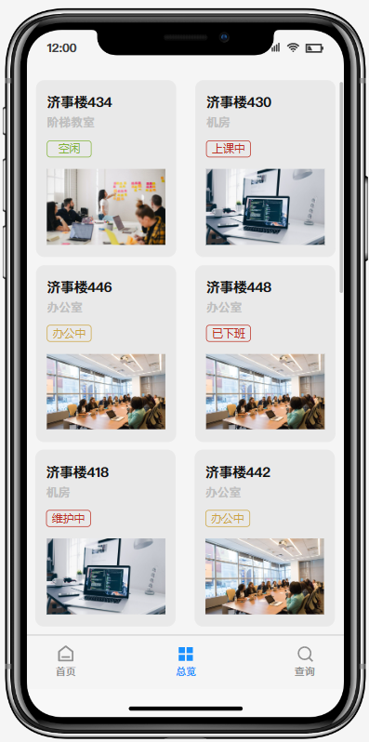

### 2) Overview page

The overview page contains multiple cards, each of which is made up of the name, the type and the state of a specific room.

This page uses a card-based layout to present each room as a distinct unit, allowing users to quickly scan and identify relevant information. The cards are visually appealing, with clear boundaries and appropriate spacing between them for ease of interaction, and the room name, type, and state is prominent and easily readable within each card. Also, the card interactions for touch devices are optimized by incorporating gestures like swipe to dismiss or swipe to access additional options, and the cards are touch-friendly, with adequate spacing and size for comfortable tapping on smaller screens.

### 3) Search page

The search page contains an input box for keywords, a list of frequently searched rooms and a list of previously searched rooms.

The search input box is placed prominently at the top of the page, making it easily visible and accessible to users. It provides placeholder text within the input box to guide users on how to perform a search and it implements auto-suggestions to assist users as they type, offering relevant room names or keywords.

The two room lists enable users to click or tap on a frequently searched room to instantly perform a search for that specific room. For previous searched rooms list, the history searched rooms are displayed in reverse chronological order, with the most recent searches appearing at the top.

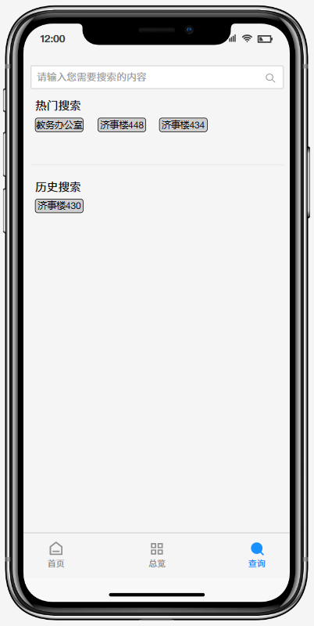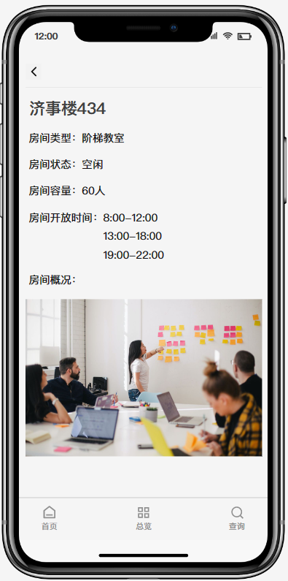

### 4) Detailed information page

The detailed information page for each room includes the name, the type, the state, the open time, the capacity, and the picture of the room.

First, for each page, it includes a header at the top of the page with a back button to allow users to navigate back to the previous page, wherever they are from.

Then, in the room details part, it arranges the details in a logical and easy-to-read manner.

Lastly, for the picture of the room, it displays a high-quality picture of the room prominently on the page, providing users with a visual representation of the space.

### 5) Navigation bar

Throughout the whole app, there is a navigation bar in the bottom of each page. It remains accessible throughout the app, allowing users to switch between different sections or pages effortlessly.

In the navigation bar, it uses clear and descriptive labels for navigation options to provide users with a clear understanding of the available destinations. It also implements a navigation trail to indicate the user's current location within the app and enable easy backward navigation. Finally, it incorporates intuitive icons for common actions, such as a home icon for returning to the main page.